# Experiment No. 2 Date:

Crimping RJ 45 Connectors

**Aim:-** To perform crimping of RJ 45 Connectors.

# Theory:

Apparatus (Components)

1. **RJ45 Connector**: This is a standardized physical connector used for Ethernet connections. It's typically used to terminate Ethernet cables, enabling them to be connected to networking devices such as switches, routers, computers, etc.

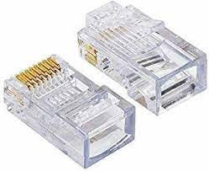

1. **Crimping Tool**: A crimping tool is used to attach the RJ45 connector onto the end of an Ethernet cable. It's used to securely fasten the connector onto the cable by crimping (pressing) the connector onto the cable's wires, ensuring a proper electrical connection.

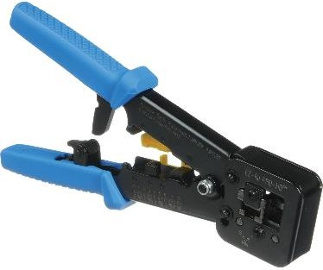

1. **Uncrimped LAN Cable**: This likely refers to a standard Ethernet cable (often called LAN cable) that hasn't

been terminated with connectors yet. These cables typically consist of multiple twisted pairs of wires inside an outer insulation jacket. They're used for transmitting data in Ethernet networks.

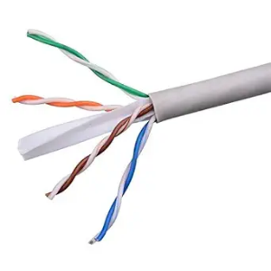

1. **LAN Tester**: A LAN tester is a tool used to verify the integrity and connectivity of Ethernet cables. It's used to check for continuity, correct wiring, and sometimes to identify faults or breaks in the cable. LAN testers can provide visual or audible feedback to indicate whether a cable is functioning properly



Procedure:

1. Start by stripping off about 2 inches of the plastic jacket off the end of the cable. Be very careful at this point, as to not nick or cut into the wires, which are inside. Doing so could alter the characteristics of your cable, or even worse render is useless. Check the wires, one more time for nicks or cuts. If there are any, just whack the whole end off, and start over.
2. Spread the wires apart, but be sure to hold onto the base of the jacket with your other hand. You do not want the wires to become untwisted down inside the jacket. Category 5 cable must only have 1/2 of an inch of 'untwisted' wire at the end; otherwise it will be 'out of spec'. At this point, you obviously have ALOT more than 1/2 of an inch of untwisted wire.
3. You have 2 end jacks, which must be installed on your cable. If you are using a pre-made cable, with one of the ends whacked off, you only have one end to install - the crossed over end. Below are two diagrams, which show how you need to arrange the cables for each type of cable end. Decide at this point which end you are making and examine the associated picture below.

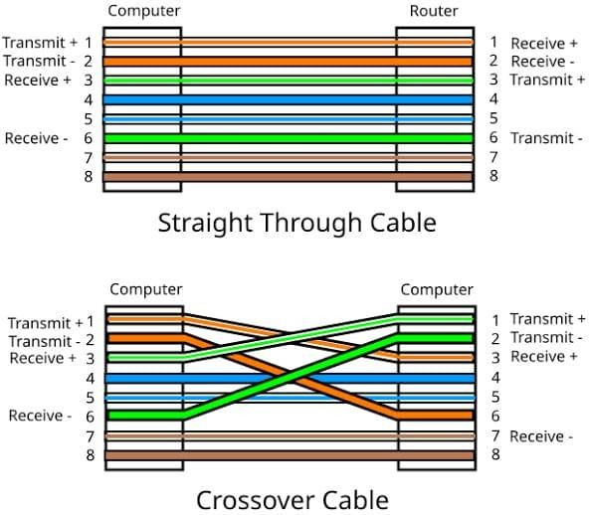

**Conclusion:** Performing Crimping of RJ 45 connectors used in LAN was done successfully.